**Travel information advisor**

学号： 2023337621159 姓名: 代翔

1. Problem Description

The design of this course requires the design and implementation of a program that provides travel information to users with different preferences, including the following needs: minimum travel time; Minimal travel costs; Minimal number of transfers. We can abstract the correlation between the distance data into a data structure diagram, and then use the Dijkstra algorithm to calculate the optimal path for each case. Then, the express generator framework in the node.js supplements the relevant front-end code and back-end code to realize the interaction between GUI and input and output.

2. Data Structure Design

*Data structure declaration + explanation*

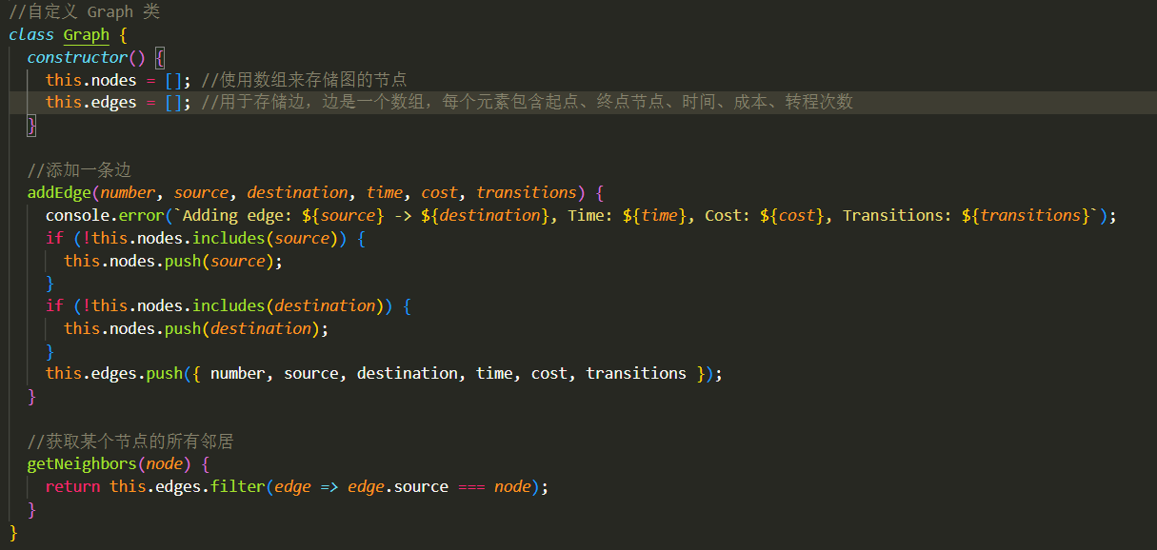

I customized a Graph class, and the constructor in the Graph class generates two arrays, nodes[] is used to store nodes in the graph, and egdes[] is used to store the edges in the graph (each edge contains the start point, end point, time, cost, and number of transitions); It contains two member functions, one is addEdge(number, source, destination, time, cost, transitions) to add edges to egdes[], and at the same time to add nodes that are not added to node[], and the other member function is to find all the neighbors of a node, use the arrow function as the callback function of fillter(), and return an array of neighbors of a node after filtering.

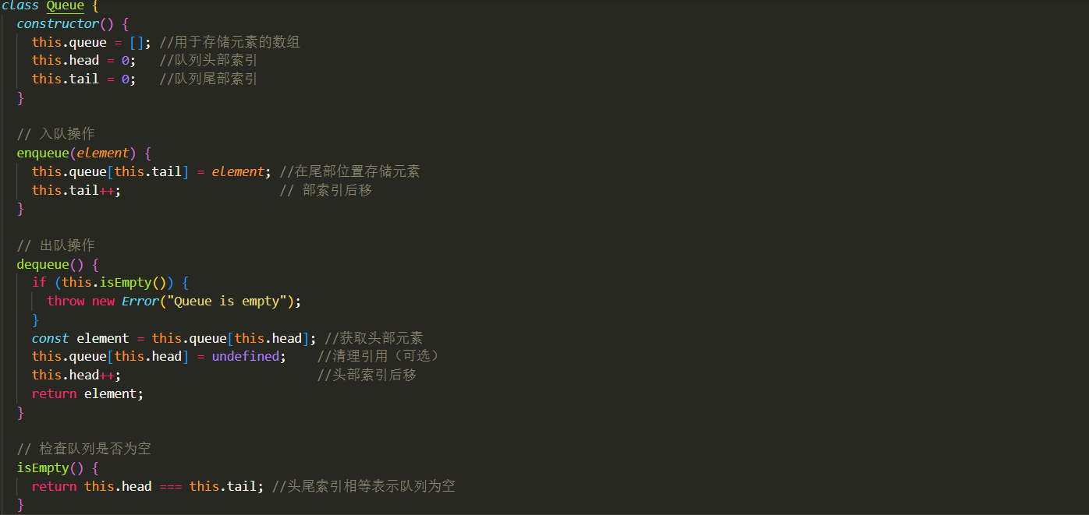

I customized a Queue class to implement the dijktra algorithm to calculate the optimal path. Initialize tail, head, and array queue at constructor time; I have defined three member functions, the first is enqueue for enqueuement, which is implemented by the movement of the trailing plug and tail pointer; The second is the dequeue function used to queue out, if it is empty, an error will be thrown, and if there is no error, the pointer will be moved back, the header data will be recorded, and then cleared to return the data; The third is to determine if the queue is empty, and return true if the head pointer is equal to the tail pointer

3.Algorithm Design and Implementation

*Algorithm description (steps, pseudo code, chart)*

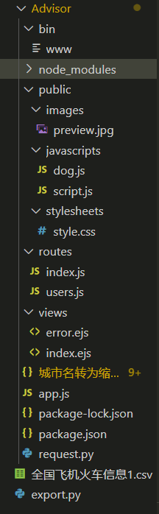

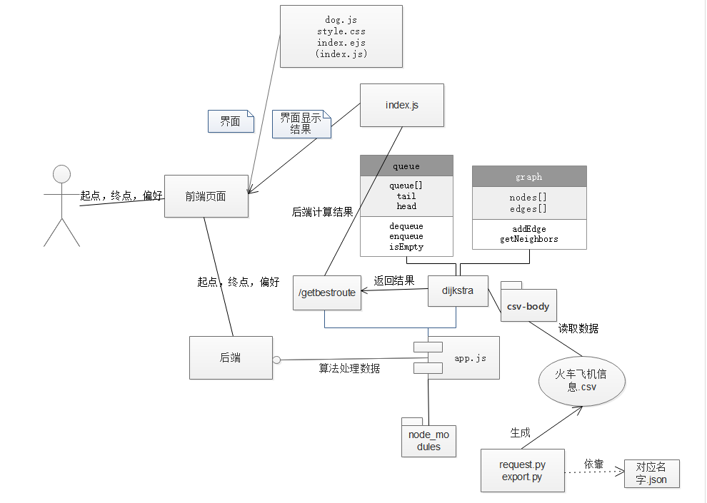

*Key code+ explanation*

***DIJKSTRA***

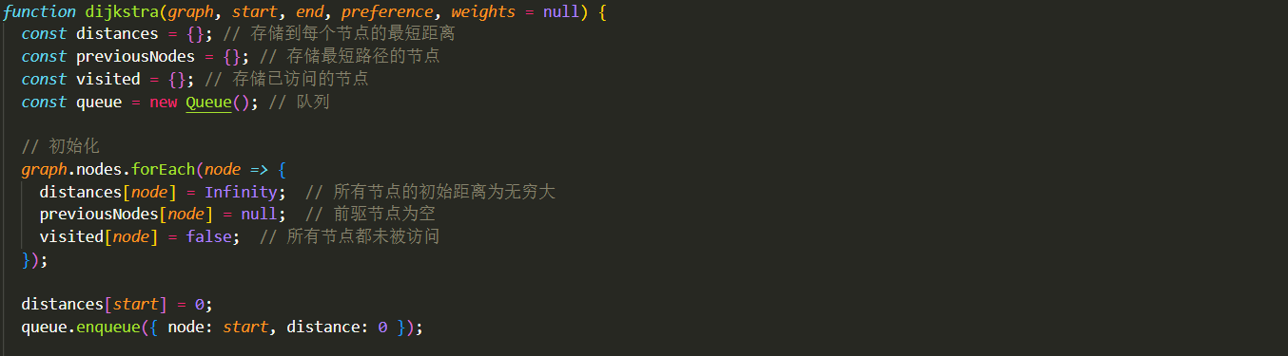

This code is an initialization operation in dijistra, distances is used to store the shortest path of each node, previous is used to store the previous node on the shortest path, visited is used to store whether this node has been traversed, and queue is used to process the traversal graph. The distance of all nodes initialized is infinity, and the precursor nodes are all empty and none are visited. Next, assign the distance from the starting point to 0 and put it in the queue.

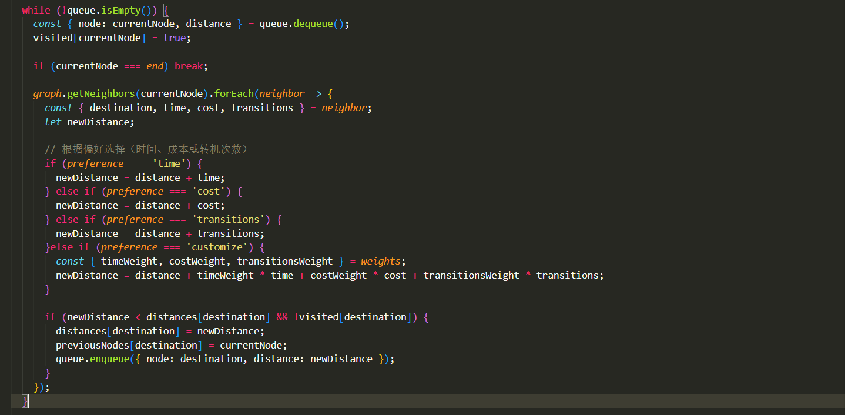

This is the core part of this code, the core part of the dijistra algorithm, when the queue is not empty, execute this loop: when the current node is not the end, dequeue the head of the queue and mark it as visited. Then call the getNeighbors method in the gragh class to obtain all the neighbors of the current node, accumulate according to various preferences, represent the value of the current node preference, compare it with the previous record, if this scheme is better, update the distance and the precursor node, and then update the node data in the queue.

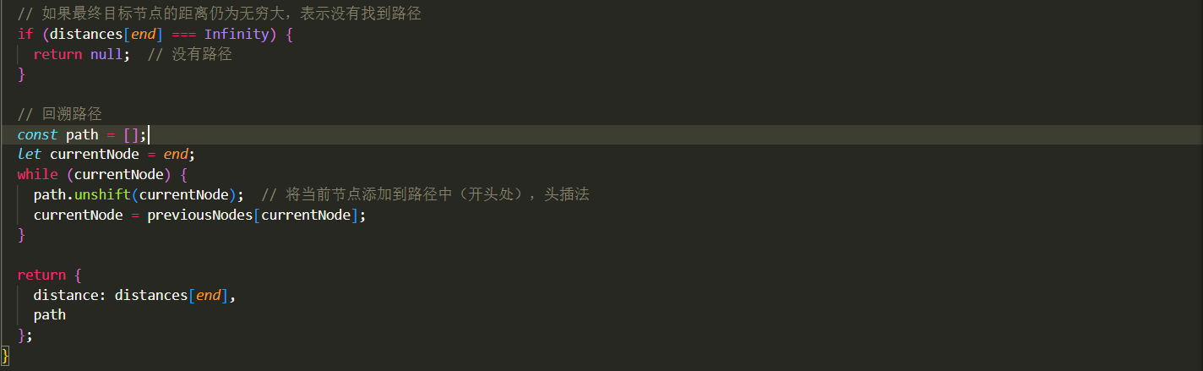

This code is a build that is used to backtrack the path to completion. If the last distance is infinite, i.e. there is no path formed, null is returned; If there is, then start from the end point and find the nodes in front of them one by one to build the shortest path. Finally, the shortest preference and path are returned.

***ROUTE(crawler)***

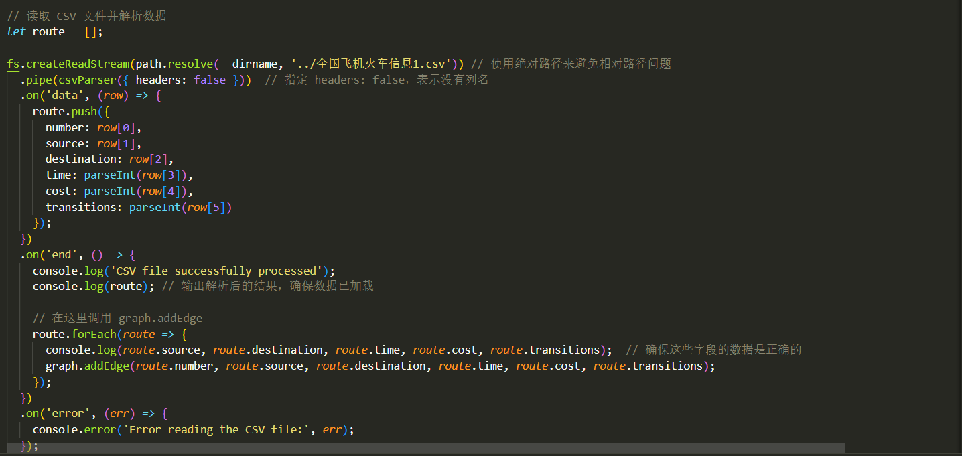

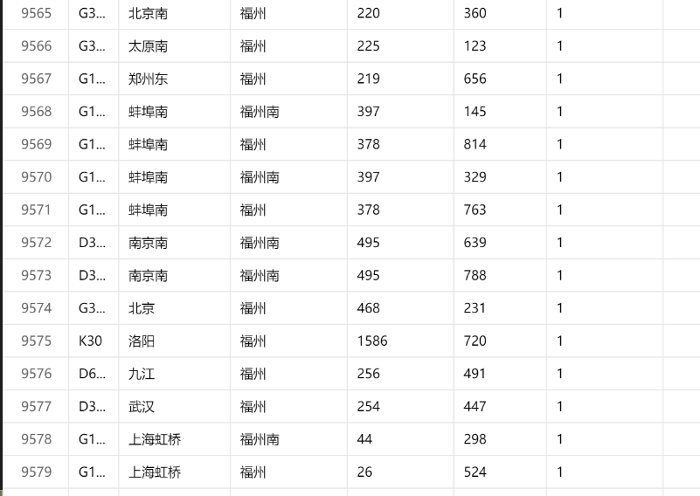

Here csv-body is used to read the csv file, and the data from the csv file is added into the graph by calling the addEdge method of the graph class.

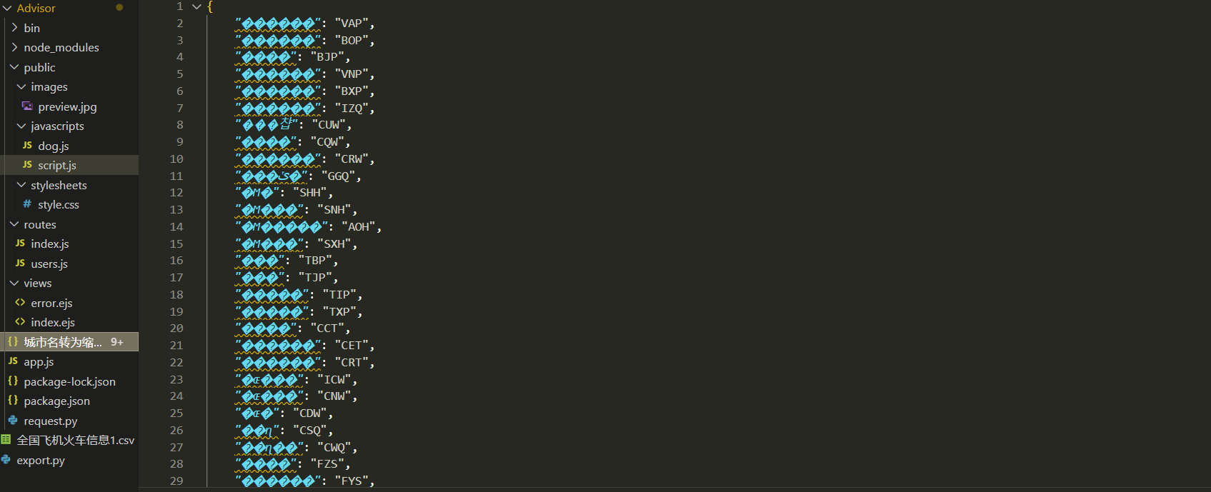

Since the crawled site name is created with specific English characters, I downloaded a json file on the network to match the English name to the Chinese 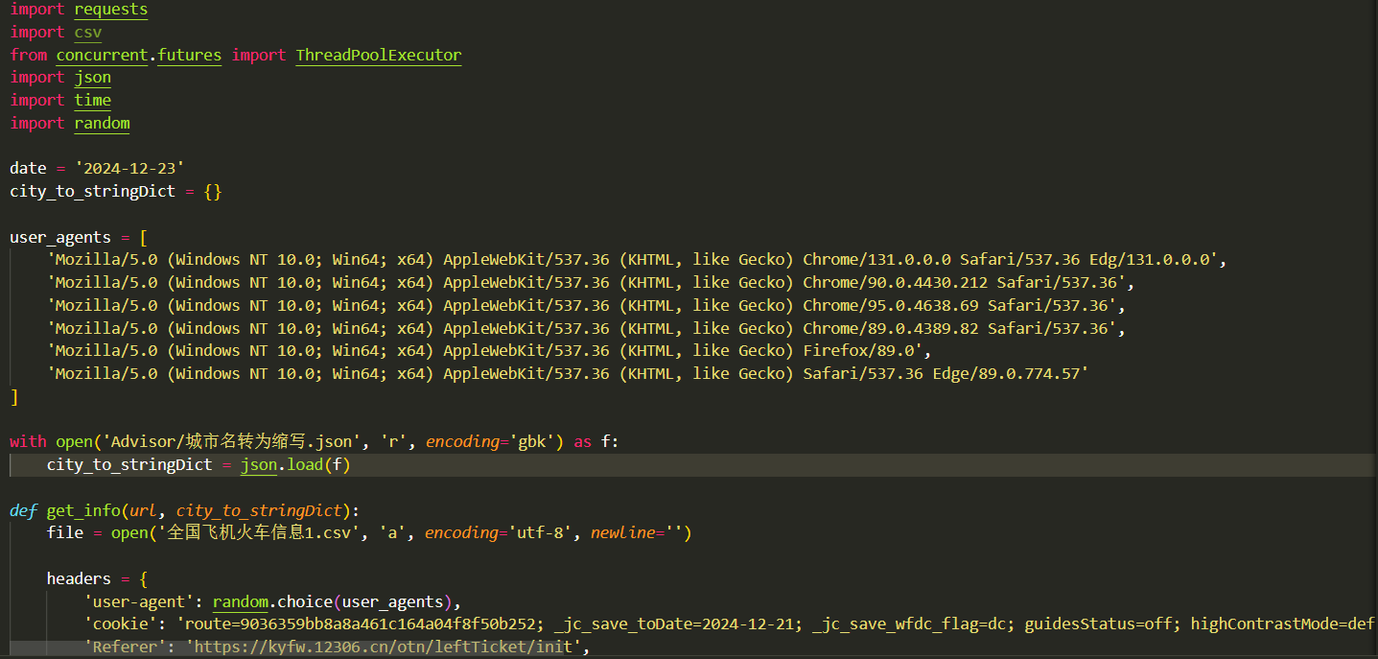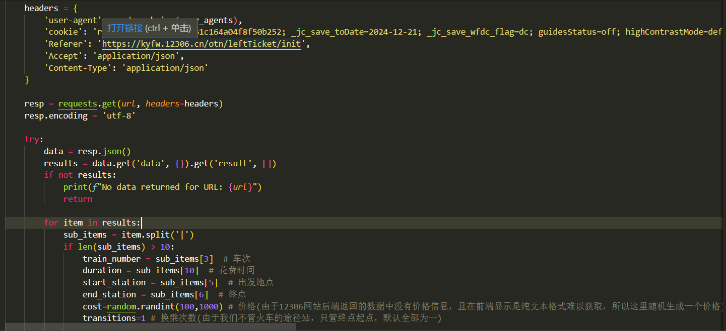

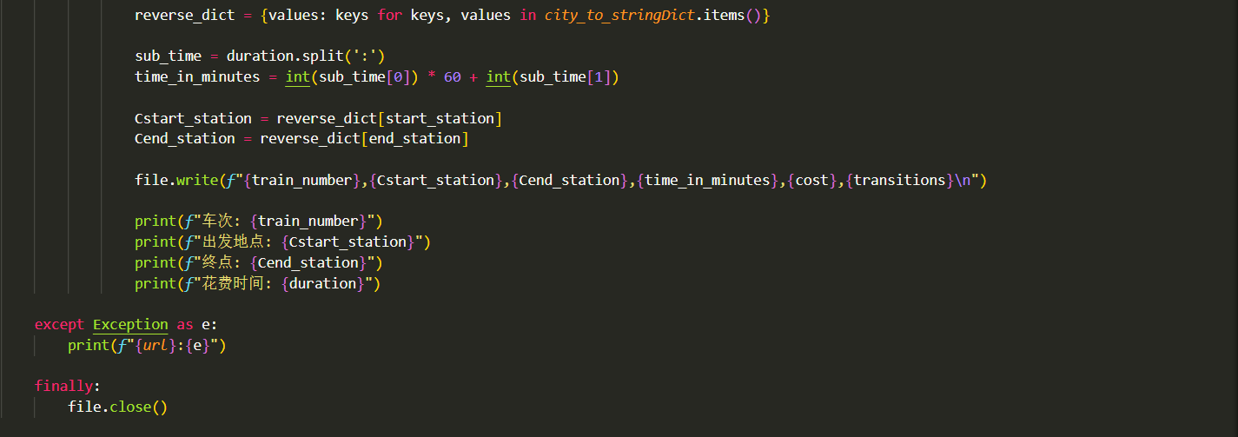

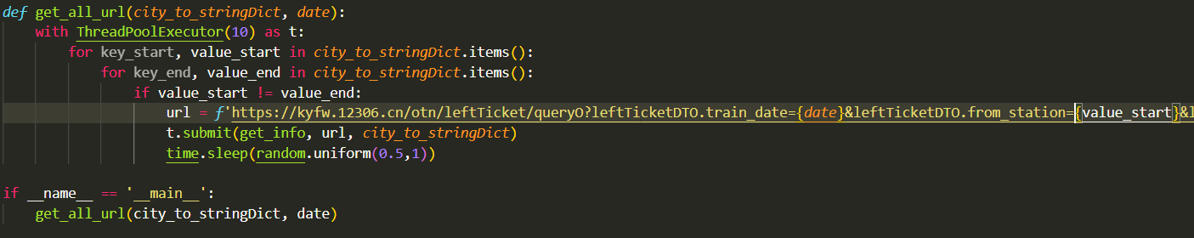

Due to the large volume of train information across the country and the anti-crawling mechanism of 12306 makes me crawl information too slow (IP is often disabled for a period of time), the multi-threaded crawler is used here to obtain only some regional train information, and because the price of the train is not easy to obtain in plain text, a random number simulation of a reasonable interval is used here. At the same time, I imagine that the train does not have intermediate stops, so I only get the start and end points, and the number of transfers at this time is also 1 by default, and the interval time is converted to minutes in real time.

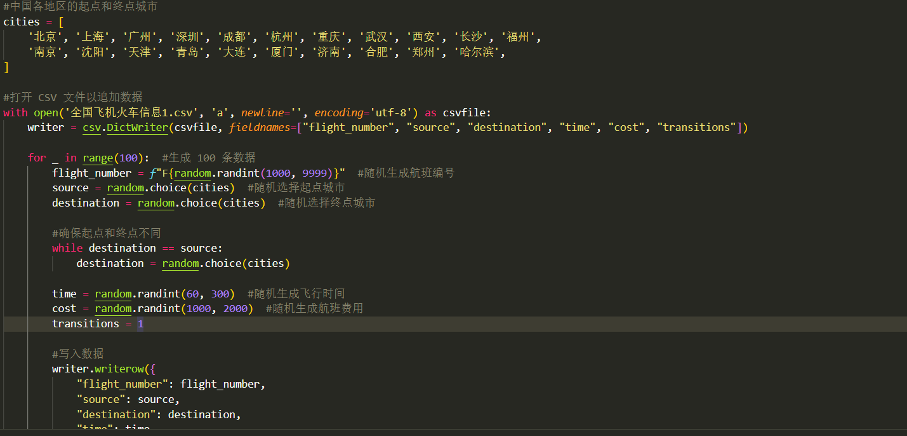

In view of the fact that the train information takes too long, it is supplemented by a randomly generated form.

***Get the best path backend***

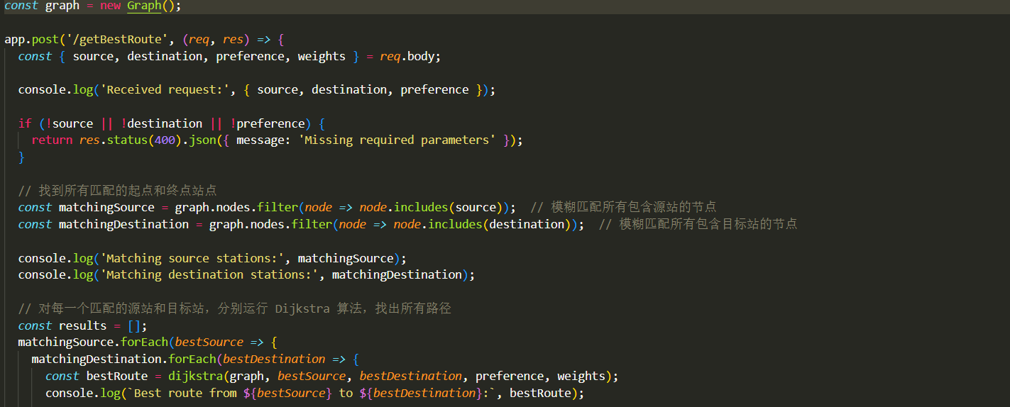

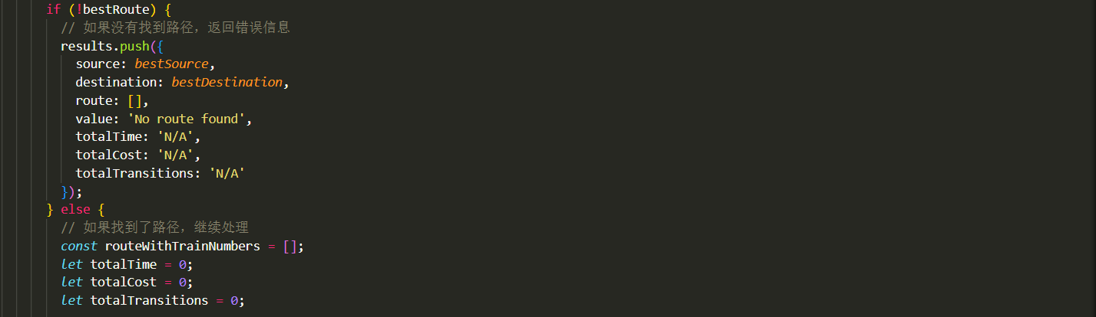

Here we make an example of a graph, and then get the data we need to use the algorithm from the request body; Use fuzzy matching to match the start and end points of user input, and then use a double loop to iterate through the start and end points of each fuzzy match to generate the corresponding path, if there is no path, return a specific format, and continue to execute the code.

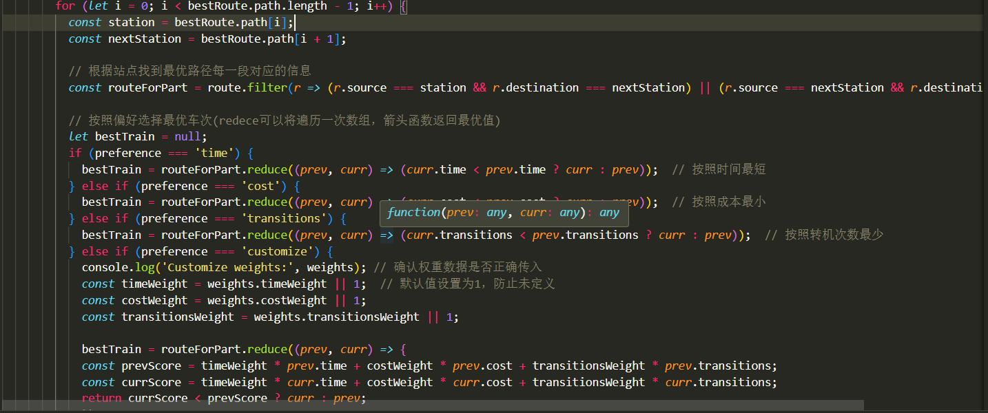

Here, according to each segment in the optimal path, the relevant information of each segment is queried, and then the relevant information is displayed according to the user's needs.

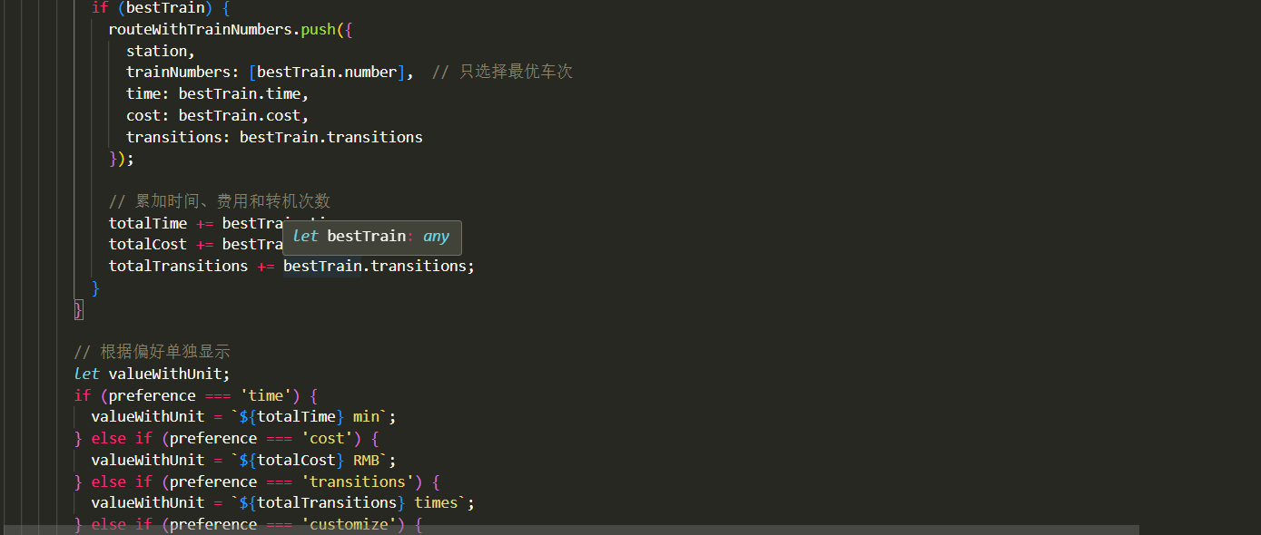

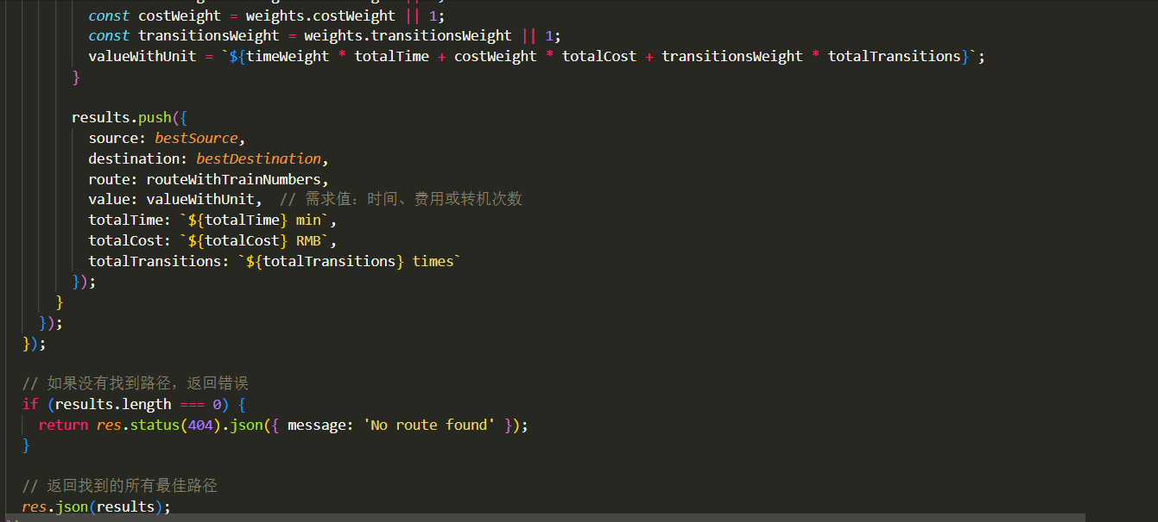

Here's a simple number processing, and each part is processed into a suitable format, which becomes JSON format.

***DOM***

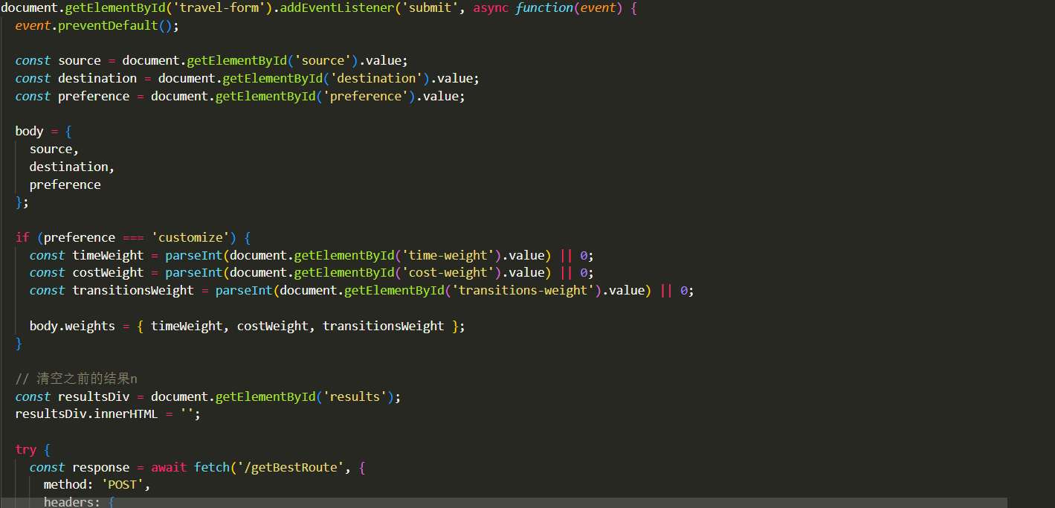

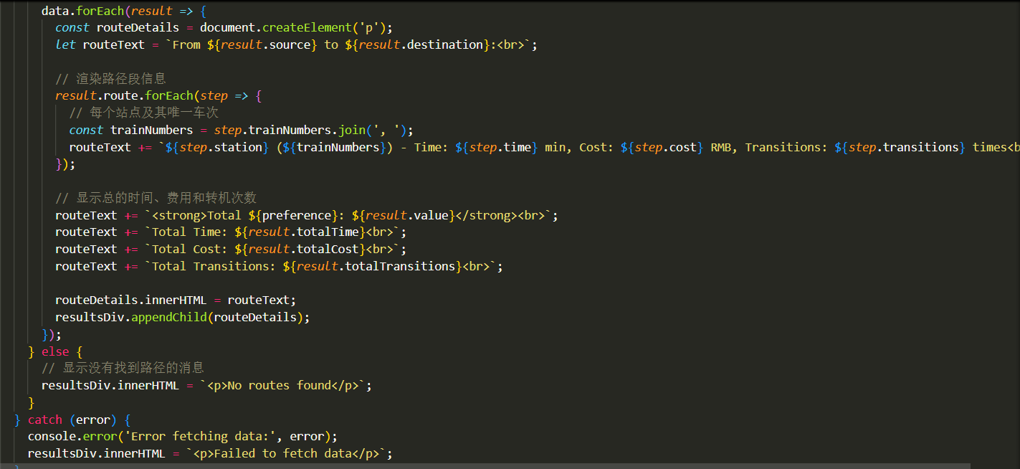

Here is the DOM event trigger after submitting the form, which is used to display the result of getting the best route.

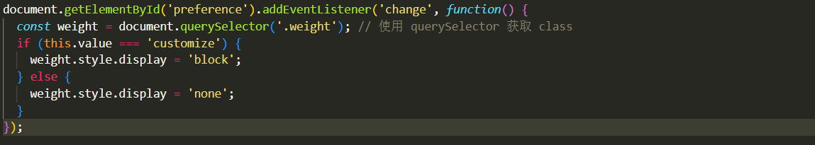

This is the input that jumps out the weights after selecting Custom.

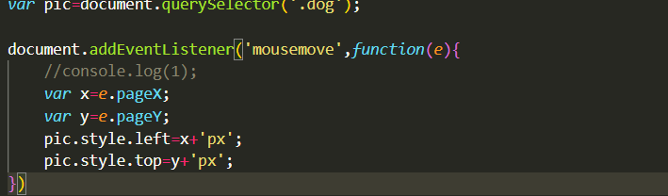

Beautify the page.

***HTML***

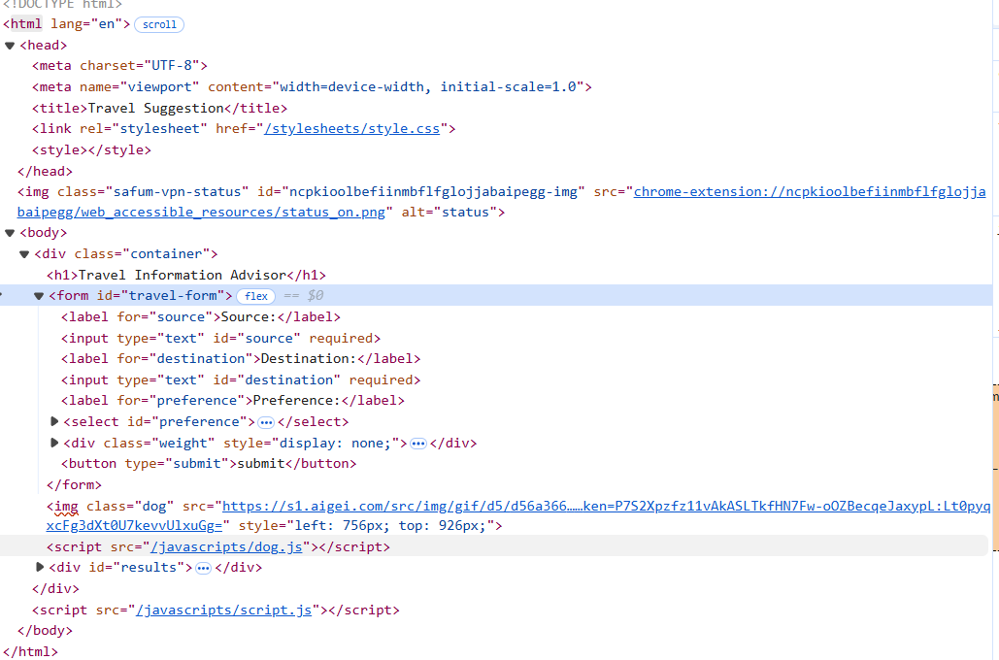

***CSS***

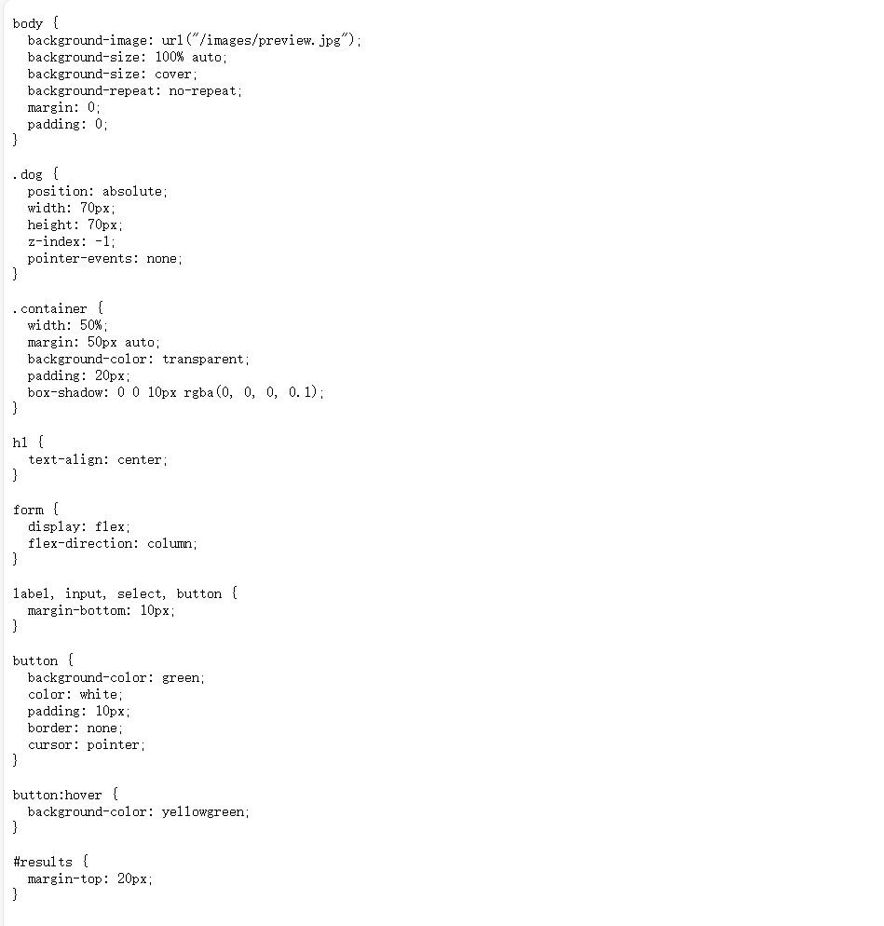

***Rendering***

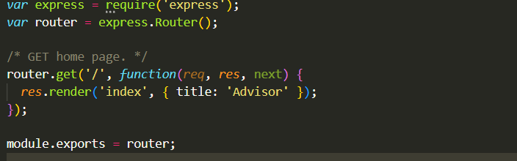

4. Results

*Inputs 🡪 outputs 【use figures】+ explanations*

*Multiple inputs to test your program, and demonstrate the* ***functionality & specificity & novelty*** *of your program.*

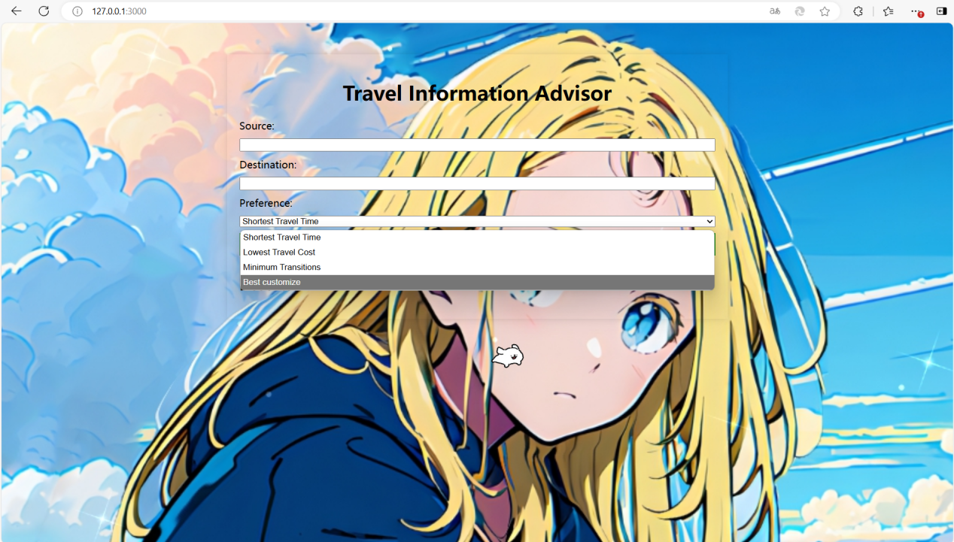

There are four options to choose from, one is the shortest time, one is the minimum cost, one is the least transfer, and one is custom.











This is the implementation of three basic functions, the particularity is that I use HTML, CSS and JavaScript to write visually, and list the transportation mode required for each journey, the time spent, the number of transfers, the amount spent, and the number of trains; The fuzzy search routes of different stations in the same place are also listed.





Here I have expanded some of the features so that customers can customize the proportion of their needs more personally, because sometimes we need more multi-faceted considerations than extreme cases, so I weighted the time, price, and number of transfers.

5. Discussion

*Discuss the strength and weakness of your solution, also about improvement and extensions if possible*

The advantage is that I use HTML, CSS, JavaScript language, use node.js as the technology stack for front-end and back-end communication, and write code under the express-genertor framework, which can make the page beautiful, easy to interact, and intuitive to obtain data. The express-genentor framework effectively separates HTML, JavaScript, CSS code, and other static resources in a clear and efficient manner. And the train data obtained by the csv file comes from my crawling of 12306 data, which is partly true.

The disadvantage is that some of the crawled data is not real, due to the technical limitations, the amount of data is randomly generated, and it takes too long to crawl, and the IP is often blocked, which can be optimized. It is also possible that the data presentation is not intuitive enough, you can consider using a map and then highlighting the route.

6 Setup information

How to run the program?

//describe the way run your program (which file to be run?)

**First of all, you need to install node.js on your computer, and configure the node.js and npm into the environment variables, use npm i in the app.js terminal to download the default package, and then download the express, csv-body package,also download nodemon.**

Please provide essential information for the user to operate your software

**Enter npm start in the app.js terminal and open the URL 127.0.0.1:3000 in your browser，CTRL+C stop.**

Appendix: (code)

The folder bin public node_moudles omitted

Index.js

*var* express = require('express');

*var* router = express.Router();

/* GET home page. */

router.get('/', *function*(*req*, *res*, next) {

*res*.render('index', { title: 'Advisor' });

});

module.exports = router;

User.js

*var* express = require('express');

*var* router = express.Router();

/* GET users listing. */

router.get('/', *function*(*req*, *res*, next) {

*res*.send('respond with a resource');

});

module.exports = router;

Error.ejs

<h1><%= message %></h1>

<h2><%= error.status %></h2>

<pre><%= error.stack %></pre>

Index.ejs

<!DOCTYPE html>

<html lang="en">

<head>

  <meta charset="UTF-8">

  <meta name="viewport" content="width=device-width, initial-scale=1.0">

  <title>Travel Suggestion</title>

  <link rel="stylesheet" href="/stylesheets/style.css">

  <style></style>

</head>

<body>

  <div class="container">

    <h1>Travel Information Advisor</h1>

    <form id="travel-form">

      <label for="source">Source:</label>

      <input type="text" id="source" required>

      <label for="destination">Destination:</label>

      <input type="text" id="destination" required>

      <label for="preference">Preference:</label>

      <select id="preference">

        <option value="time">Shortest Travel Time</option>

        <option value="cost">Lowest Travel Cost</option>

        <option value="transitions">Minimum Transitions</option>

        <option value="customize">Best customize</option>

      </select>

      <div class="weight" style="display: none;">

        <label for="time weight">time weighr:</label>

        <input type="number" id="time-weight" min="0" max="10" placeholder="ex: 1">

        <label for="cost weight">cost weight:</label>

        <input type="number" id="cost-weight" min="0" max="10" placeholder="ex: 1">

        <label for="transition weight">transiton weight:</label>

        <input type="number" id="transitions-weight" min="0" max="10" placeholder="ex: 1">

      </div>

      <button type="submit">submit</button>

    </form>

    <img class="dog" src="https://s1.aigei.com/src/img/gif/d5/d56a366a49d946d991ed49d1613202cb.gif?imageMogr2/auto-orient/thumbnail/!282x282r/gravity/Center/crop/282x282/quality/85/%7CimageView2/2/w/282&e=2051020800&token=P7S2Xpzfz11vAkASLTkfHN7Fw-oOZBecqeJaxypL:Lt0pyqxcFg3dXt0U7kevvUlxuGg=">

    <script src="/javascripts/dog.js"></script>

    <div id="results">

      <h2>Results:</h2>

    </div>

  </div>

  <script src="/javascripts/script.js"></script>

</body>

</html>

App.js

*var* createError = require('http-errors');

*var* express = require('express');

*var* path = require('path');

*var* cookieParser = require('cookie-parser');

*var* logger = require('morgan');

*var* bodyParser = require('body-parser');  // 添加 body-parser 模块

*var* csvParser = require('csv-parser');    // 引入 csv-parser 模块

*var* fs = require('fs');

*var* indexRouter = require('./routes/index');

*var* usersRouter = require('./routes/users');

*var* app = express();

// 读取 CSV 文件并解析数据

*let* route = [];

fs.createReadStream(path.resolve(__dirname, '../全国飞机火车信息1.csv')) // 使用绝对路径来避免相对路径问题

  .pipe(csvParser({ headers: false }))  // 指定 headers: false，表示没有列名

  .on('data', (*row*) *=>* {

    route.push({

      number: *row*[0],

      source: *row*[1],

      destination: *row*[2],

      time: parseInt(*row*[3]),

      cost: parseInt(*row*[4]),

      transitions: parseInt(*row*[5])

    });

  })

  .on('end', () *=>* {

    console.log('CSV file successfully processed');

    console.log(route); // 输出解析后的结果，确保数据已加载

    // 在这里调用 graph.addEdge

    route.forEach(*route* *=>* {

      console.log(*route*.source, *route*.destination, *route*.time, *route*.cost, *route*.transitions);  // 确保这些字段的数据是正确的

      graph.addEdge(*route*.number, *route*.source, *route*.destination, *route*.time, *route*.cost, *route*.transitions);

    });

  })

  .on('error', (*err*) *=>* {

    console.error('Error reading the CSV file:', *err*);

  });

// 自定义 Graph 类

*class* Graph {

*constructor*() {

    this.nodes = []; // 使用数组来存储图的节点

    this.edges = []; // 用于存储边，边是一个数组，每个元素包含起点、终点节点、时间、成本、转程次数

  }

  // 添加一条边

  addEdge(*number*, *source*, *destination*, *time*, *cost*, *transitions*) {

    console.error(`Adding edge: ${*source*} -> ${*destination*}, Time: ${*time*}, Cost: ${*cost*}, Transitions: ${*transitions*}`);

    if (!this.nodes.includes(*source*)) {

      this.nodes.push(*source*);

    }

    if (!this.nodes.includes(*destination*)) {

      this.nodes.push(*destination*);

    }

    this.edges.push({ number, source, destination, time, cost, transitions });

  }

  // 获取某个节点的所有邻居

  getNeighbors(*node*) {

    return this.edges.filter(*edge* *=>* *edge*.source === *node*);

  }

}

*class* Queue {

*constructor*() {

    this.queue = []; // 用于存储元素的数组

    this.head = 0;   // 队列头部索引

    this.tail = 0;   // 队列尾部索引

  }

  // 入队操作

  enqueue(*element*) {

    this.queue[this.tail] = *element*; // 在尾部位置存储元素

    this.tail++;                     // 部索引后移

  }

  // 出队操作

  dequeue() {

    if (this.isEmpty()) {

      throw new *Error*("Queue is empty");

    }

*const* element = this.queue[this.head]; // 获取头部元素

    this.queue[this.head] = undefined;    // 清理引用（可选）

    this.head++;                          // 头部索引后移

    return element;

  }

  // 检查队列是否为空

  isEmpty() {

    return this.head === this.tail; // 头尾索引相等表示队列为空

  }

}

*function* dijkstra(*graph*, *start*, *end*, *preference*, *weights* = null) {

*const* distances = {}; // 存储到每个节点的最短距离

*const* previousNodes = {}; // 存储最短路径的前驱节点

*const* visited = {}; // 存储已访问的节点

*const* queue = new Queue(); // 队列

  // 初始化

*graph*.nodes.forEach(*node* *=>* {

    distances[*node*] = Infinity;  // 所有节点的初始距离为无穷大

    previousNodes[*node*] = null;  // 前驱节点为空

    visited[*node*] = false;  // 所有节点都未被访问

  });

  distances[*start*] = 0;

  queue.enqueue({ node: *start*, distance: 0 });

  while (!queue.isEmpty()) {

*const* { node: currentNode, distance } = queue.dequeue();

    visited[currentNode] = true;

    if (currentNode === *end*) break;

*graph*.getNeighbors(currentNode).forEach(*neighbor* *=>* {

*const* { destination, time, cost, transitions } = *neighbor*;

*let* newDistance;

      // 根据偏好选择（时间、成本或转机次数）

      if (*preference* === 'time') {

        newDistance = distance + time;

      } else if (*preference* === 'cost') {

        newDistance = distance + cost;

      } else if (*preference* === 'transitions') {

        newDistance = distance + transitions;

      }else if (*preference* === 'customize') {

*const* { timeWeight, costWeight, transitionsWeight } = *weights*;

        newDistance = distance + timeWeight * time + costWeight * cost + transitionsWeight * transitions;

      }

      if (newDistance < distances[destination] && !visited[destination]) {

        distances[destination] = newDistance;

        previousNodes[destination] = currentNode;

        queue.enqueue({ node: destination, distance: newDistance });

      }

    });

  }

  // 如果最终目标节点的距离仍为无穷大，表示没有找到路径

  if (distances[*end*] === Infinity) {

    return null;  // 没有路径

  }

  // 回溯路径

*const* path = [];

*let* currentNode = *end*;

  while (currentNode) {

    path.unshift(currentNode);  // 将当前节点添加到路径中（开头处），头插法

    currentNode = previousNodes[currentNode];

  }

  return {

    distance: distances[*end*],

    path

  };

}

app.set('views', path.join(__dirname, 'views'));

app.set('view engine', 'ejs');

app.use(logger('dev'));

app.use(express.json());

app.use(express.urlencoded({ extended: false }));

app.use(cookieParser());

app.use(express.static(path.join(__dirname, 'public')));

app.use(bodyParser.json());

// 创建图实例

*const* graph = new Graph();

app.post('/getBestRoute', (*req*, *res*) *=>* {

*const* { source, destination, preference, weights } = *req*.body;

  console.log('Received request:', { source, destination, preference });

  if (!source || !destination || !preference) {

    return *res*.status(400).json({ message: 'Missing required parameters' });

  }

  // 找到所有匹配的起点和终点站点

*const* matchingSource = graph.nodes.filter(*node* *=>* *node*.includes(source));  // 模糊匹配所有包含源站的节点

*const* matchingDestination = graph.nodes.filter(*node* *=>* *node*.includes(destination));  // 模糊匹配所有包含目标站的节点

  console.log('Matching source stations:', matchingSource);

  console.log('Matching destination stations:', matchingDestination);

  // 对每一个匹配的源站和目标站，分别运行 Dijkstra 算法，找出所有路径

*const* results = [];

  matchingSource.forEach(*bestSource* *=>* {

    matchingDestination.forEach(*bestDestination* *=>* {

*const* bestRoute = dijkstra(graph, *bestSource*, *bestDestination*, preference, weights);

      console.log(`Best route from ${*bestSource*} to ${*bestDestination*}:`, bestRoute);

      if (!bestRoute) {

        // 如果没有找到路径，返回错误信息

        results.push({

          source: *bestSource*,

          destination: bestDestination,

          route: [],

          value: 'No route found',

          totalTime: 'N/A',

          totalCost: 'N/A',

          totalTransitions: 'N/A'

        });

      } else {

        // 如果找到了路径，继续处理

*const* routeWithTrainNumbers = [];

*let* totalTime = 0;

*let* totalCost = 0;

*let* totalTransitions = 0;

        // 遍历路径段

        for (*let* i = 0; i < bestRoute.path.length - 1; i++) {

*const* station = bestRoute.path[i];

*const* nextStation = bestRoute.path[i + 1];

          // 根据站点找到最优路径每一段对应的信息

*const* routeForPart = route.filter(*r* *=>* (*r*.source === station && *r*.destination === nextStation) || (*r*.source === nextStation && *r*.destination === station));

          // 按照偏好选择最优车次(redece可以将遍历一次数组，箭头函数返回最优值)

*let* bestTrain = null;

          if (preference === 'time') {

            bestTrain = routeForPart.reduce((*prev*, *curr*) *=>* (*curr*.time < *prev*.time ? *curr* : *prev*));  // 按照时间最短

          } else if (preference === 'cost') {

            bestTrain = routeForPart.reduce((*prev*, *curr*) *=>* (*curr*.cost < *prev*.cost ? *curr* : *prev*));  // 按照成本最小

          } else if (preference === 'transitions') {

            bestTrain = routeForPart.reduce((*prev*, *curr*) *=>* (curr.transitions < prev.transitions ? curr : prev));  // 按照转机次数最少

          } else if (preference === 'customize') {

            console.log('Customize weights:', weights); // 确认权重数据是否正确传入

*const* timeWeight = weights.timeWeight || 1;  // 默认值设置为1，防止未定义

*const* costWeight = weights.costWeight || 1;

*const* transitionsWeight = weights.transitionsWeight || 1;

            bestTrain = routeForPart.reduce((*prev*, *curr*) *=>* {

*const* prevScore = timeWeight * *prev*.time + costWeight * *prev*.cost + transitionsWeight * *prev*.transitions;

*const* currScore = timeWeight * *curr*.time + costWeight * *curr*.cost + transitionsWeight * *curr*.transitions;

            return currScore < prevScore ? *curr* : *prev*;

            });

          }

          // 选择最优车次

          if (bestTrain) {

            routeWithTrainNumbers.push({

              station,

              trainNumbers: [bestTrain.number],  // 只选择最优车次

              time: bestTrain.time,

              cost: bestTrain.cost,

              transitions: bestTrain.transitions

            });

            // 累加时间、费用和转机次数

            totalTime += bestTrain.time;

            totalCost += bestTrain.cost;

            totalTransitions += bestTrain.transitions;

          }

        }

        // 根据偏好单独显示

*let* valueWithUnit;

        if (preference === 'time') {

          valueWithUnit = `${totalTime} min`;

        } else if (preference === 'cost') {

          valueWithUnit = `${totalCost} RMB`;

        } else if (preference === 'transitions') {

          valueWithUnit = `${totalTransitions} times`;

        } else if (preference === 'customize') {

*const* timeWeight = weights.timeWeight || 1;

*const* costWeight = weights.costWeight || 1;

*const* transitionsWeight = weights.transitionsWeight || 1;

          valueWithUnit = `${timeWeight * totalTime + costWeight * totalCost + transitionsWeight * totalTransitions}`;

        }

        results.push({

          source: *bestSource*,

          destination: bestDestination,

          route: routeWithTrainNumbers,

          value: valueWithUnit,  // 需求值：时间、费用或转机次数

          totalTime: `${totalTime} min`,

          totalCost: `${totalCost} RMB`,

          totalTransitions: `${totalTransitions} times`

        });

      }

    });

  });

  // 如果没有找到路径，返回错误

  if (results.length === 0) {

    return *res*.status(404).json({ message: 'No route found' });

  }

  // 返回找到的所有最佳路径

*res*.json(results);

});

// 基本路由

app.use('/', indexRouter);

app.use('/users', usersRouter);

// catch 404 and forward to error handler

app.use(*function*(*req*, *res*, next) {

  next(createError(404));

});

// error handler

app.use(*function*(*err*, *req*, *res*, *next*) {

*res*.locals.message = *err*.message;

*res*.locals.error = *req*.app.get('env') === 'development' ? *err* : {};

*res*.status(*err*.status || 500);

*res*.render('error');

});

module.*exports* = app;

Request.py

import requests

import csv

from concurrent.futures import ThreadPoolExecutor

import json

import time

import random

date = '2024-12-23'

city_to_stringDict = {}

user_agents = [

    'Mozilla/5.0 (Windows NT 10.0; Win64; x64) AppleWebKit/537.36 (KHTML, like Gecko) Chrome/131.0.0.0 Safari/537.36 Edg/131.0.0.0',

    'Mozilla/5.0 (Windows NT 10.0; Win64; x64) AppleWebKit/537.36 (KHTML, like Gecko) Chrome/90.0.4430.212 Safari/537.36',

    'Mozilla/5.0 (Windows NT 10.0; Win64; x64) AppleWebKit/537.36 (KHTML, like Gecko) Chrome/95.0.4638.69 Safari/537.36',

    'Mozilla/5.0 (Windows NT 10.0; Win64; x64) AppleWebKit/537.36 (KHTML, like Gecko) Chrome/89.0.4389.82 Safari/537.36',

    'Mozilla/5.0 (Windows NT 10.0; Win64; x64) AppleWebKit/537.36 (KHTML, like Gecko) Firefox/89.0',

    'Mozilla/5.0 (Windows NT 10.0; Win64; x64) AppleWebKit/537.36 (KHTML, like Gecko) Safari/537.36 Edge/89.0.774.57'

]

with open('Advisor/城市名转为缩写.json', 'r', *encoding*='gbk') as f:

    city_to_stringDict = json.load(f)

*def* get_info(*url*, *city_to_stringDict*):

    file = open('全国飞机火车信息1.csv', 'a', *encoding*='utf-8', *newline*='')

    headers = {

        'user-agent': random.choice(user_agents),

        'cookie': 'route=9036359bb8a8a461c164a04f8f50b252; _jc_save_toDate=2024-12-21; _jc_save_wfdc_flag=dc; guidesStatus=off; highContrastMode=defaltMode; cursorStatus=off; BIGipServerpassport=854065418.50215.0000; _jc_save_fromStation=%u5317%u4EAC%2CBJP; _jc_save_toStation=%u4E0A%u6D77%2CSHH; _jc_save_fromDate=2024-12-22; BIGipServerotn=217055754.24610.0000',

        'Referer': 'https://kyfw.12306.cn/otn/leftTicket/init',

        'Accept': 'application/json',

        'Content-Type': 'application/json'

    }

    resp = requests.get(*url*, *headers*=headers)

    resp.encoding = 'utf-8'

    try:

        data = resp.json()

        results = data.get('data', {}).get('result', [])

        if not results:

            print(*f*"No data returned for URL: {*url*}")

            return

        for item in results:

            sub_items = item.split('|')

            if len(sub_items) > 10:

                train_number = sub_items[3]  # 车次

                duration = sub_items[10]  # 花费时间

                start_station = sub_items[5]  # 出发地点

                end_station = sub_items[6]  # 终点

                cost=random.randint(100,1000) # 价格(由于12306网站后端返回的数据中没有价格信息，且在前端显示是纯文本格式难以获取，所以这里随机生成一个价格)

                transitions=1 # 换乘次数(由于我们不管火车的途径站，只管终点起点，默认全部为一)

                reverse_dict = {values: keys for keys, values in *city_to_stringDict*.items()}

                sub_time = duration.split(':')

                time_in_minutes = int(sub_time[0]) * 60 + int(sub_time[1])

                Cstart_station = reverse_dict[start_station]

                Cend_station = reverse_dict[end_station]

                file.write(*f*"{train_number},{Cstart_station},{Cend_station},{time_in_minutes},{cost},{transitions}\n")

                print(*f*"车次: {train_number}")

                print(*f*"出发地点: {Cstart_station}")

                print(*f*"终点: {Cend_station}")

                print(*f*"花费时间: {duration}")

    except Exception as e:

        print(*f*"{*url*}:{e}")

    finally:

        file.close()

*def* get_all_url(*city_to_stringDict*, *date*):

    with ThreadPoolExecutor(10) as t:

        for key_start, value_start in *city_to_stringDict*.items():

            for key_end, value_end in *city_to_stringDict*.items():

                if value_start != value_end:

                    url = *f*'https://kyfw.12306.cn/otn/leftTicket/queryO?leftTicketDTO.train_date={*date*}&leftTicketDTO.from_station={value_start}&leftTicketDTO.to_station={value_end}&purpose_codes=ADULT'

                    t.submit(get_info, url, *city_to_stringDict*)

                    time.sleep(random.uniform(0.5,1))

if __name__ == '__main__':

    get_all_url(city_to_stringDict, date)

Export.py

import random

import csv

#中国各地区的起点和终点城市

cities = [

    '北京', '上海', '广州', '深圳', '成都', '杭州', '重庆', '武汉', '西安', '长沙', '福州',

    '南京', '沈阳', '天津', '青岛', '大连', '厦门', '济南', '合肥', '郑州', '哈尔滨',

]

#打开 CSV 文件以追加数据

with open('全国飞机火车信息1.csv', 'a', *newline*='', *encoding*='utf-8') as csvfile:

    writer = csv.DictWriter(csvfile, *fieldnames*=["flight_number", "source", "destination", "time", "cost", "transitions"])

    for _ in range(100):  #生成 100 条数据

        flight_number = *f*"F{random.randint(1000, 9999)}"  #随机生成航班编号

        source = random.choice(cities)  #随机选择起点城市

        destination = random.choice(cities)  #随机选择终点城市

        #确保起点和终点不同

        while destination == source:

            destination = random.choice(cities)

        time = random.randint(60, 300)  #随机生成飞行时间

        cost = random.randint(1000, 2000)  #随机生成航班费用

        transitions = 1

        #写入数据

        writer.writerow({

            "flight_number": flight_number,

            "source": source,

            "destination": destination,

            "time": time,

            "cost": cost,

            "transitions": transitions

        })